**Ideation Phase**

**Brainstorm & Idea Prioritization Template**

|  |  |
| --- | --- |
| Date | 27 June 2025 |
| Team ID | LTVIP2025TMID28869 |
| Project Name | Educational Organisation |
| Maximum Marks | 4 Marks |

**Brainstorm & Idea Prioritization Template:**

Generate as many ideas as possible without judgment. Include wild, simple, and even "bad" ideas— they spark creativity. Use prompts like "What if we..." or "How might we...".Combine or tweak existing ideas to form new ones. Involve different perspectives to expand the idea pool. Group similar ideas together to spot themes or patterns. Eliminate duplicate or irrelevant ideas. Score ideas based on impact, effort, and feasibility. Use a simple 2x2 grid: high/low impact vs. high/low effort. Pick quick wins (high impact, low effort) to execute first. Prioritize ideas with a balance of originality and practicality. Reassess priorities if new information or constraints arise.

Reference: <https://www.mural.co/templates/brainstorm-and-idea-prioritization>

**Step-1: Team Gathering, Collaboration and Select the Problem Statement**

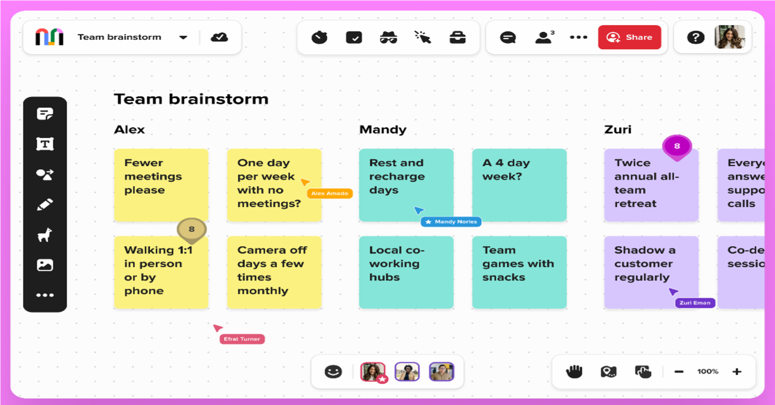

**Step-2: Brainstorm, Idea Listing and Grouping**

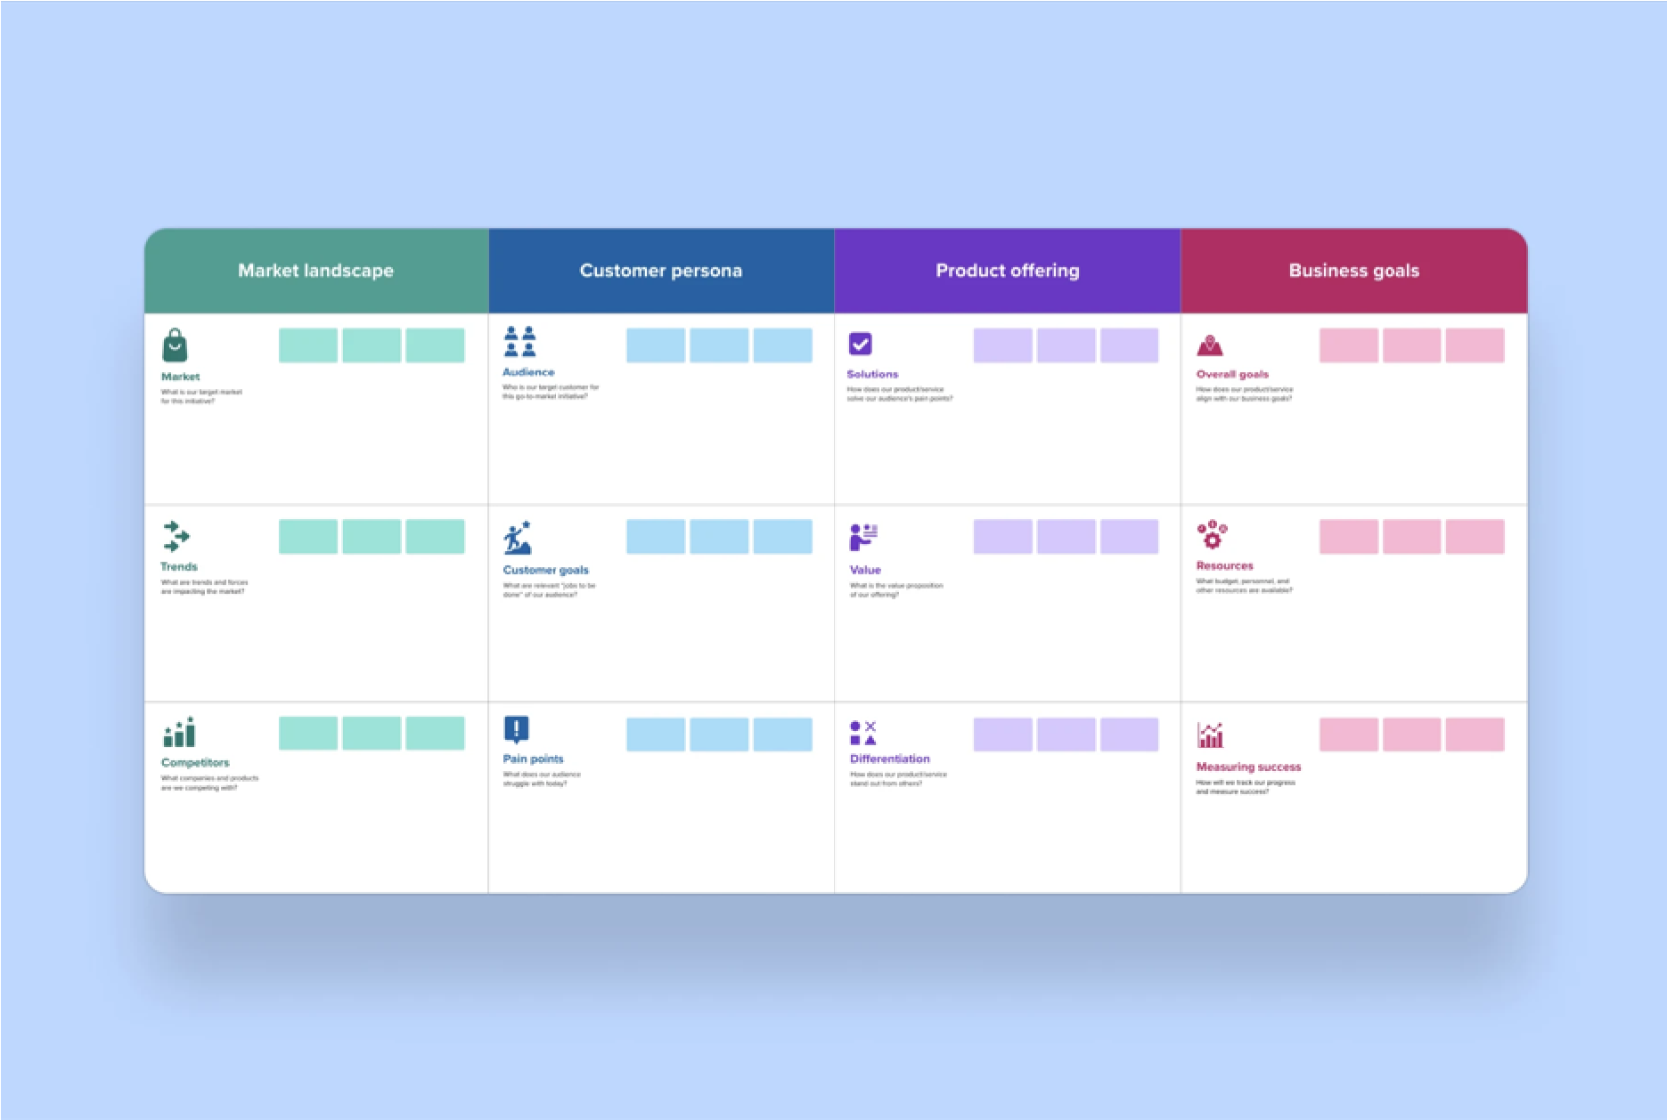

**Step-3: Idea Prioritization**

